MEETING MINUTES

# Topic: Final Design of Chamber

## Tuesday, March 28, 2017

## 2:30 pm – 3:20pm

**Minutes recorded by Sharna Beahm**

**Attendees: Sharna Beahm, Riley Ducey, Isaiah Cons**

Ion gun arrived

* Unpackaged and measured!
* 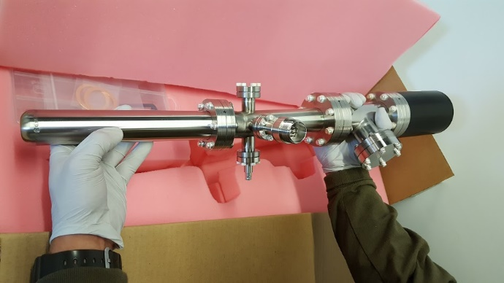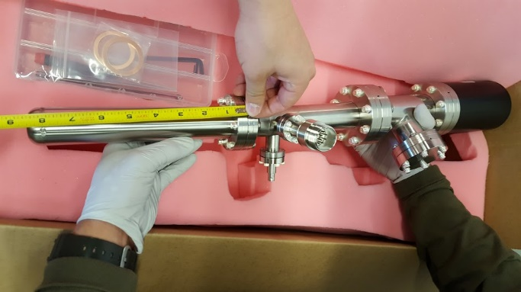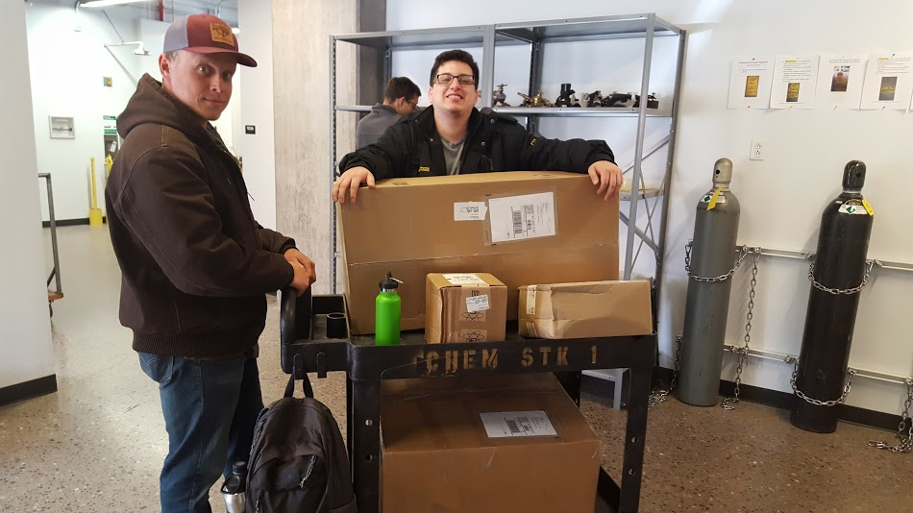

We were very excited!

* Stands
  + 3D print is being finalized by Sharna for the chamber.
  + Modifications still needed before print
  + Should be done by 3-29-17

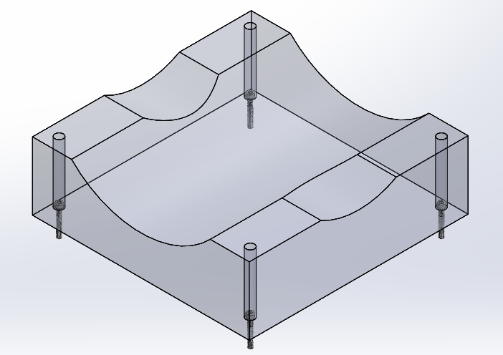

Figure: chamber support

* + Once chamber is complete TOF and ion gun stands will be designed next